**Project: Take me out to the Ballgame**

**Team: Jerryberry**

**Use case name: Add a New Team and Corresponding Stadium**

Actors:

* Administrator (is allowed to edit, add, and remove from database)
* Database System (process and manages the teams and souvenirs along with their corresponding stadium)

Triggers:

* The admin indicates that he/she wants to add a new Team/Stadium

Preconditions:

* The user is an administrator.

Post-conditions:

* A new team and corresponding stadium will be added to the database.

Normal Flow:

1. The admin enters ctrl + enter to get access to the Admin login and proceeds to enter the correct password.

2. The admin is presented with the itinerary management page.

3. The admin clicks on the “add team” button.

4. The system will prompt the admin enter name of the new team along with its corresponding stadium.

5. The admin clicks on the restart program button to verify the changes to the program.

Alternate Flows:

2A1: The admin can import data from file.

1. The admin clicks on the “add from file” button
2. The system prompts the admin to provide the pathway to the file
3. The use case returns to step 5 and continues.

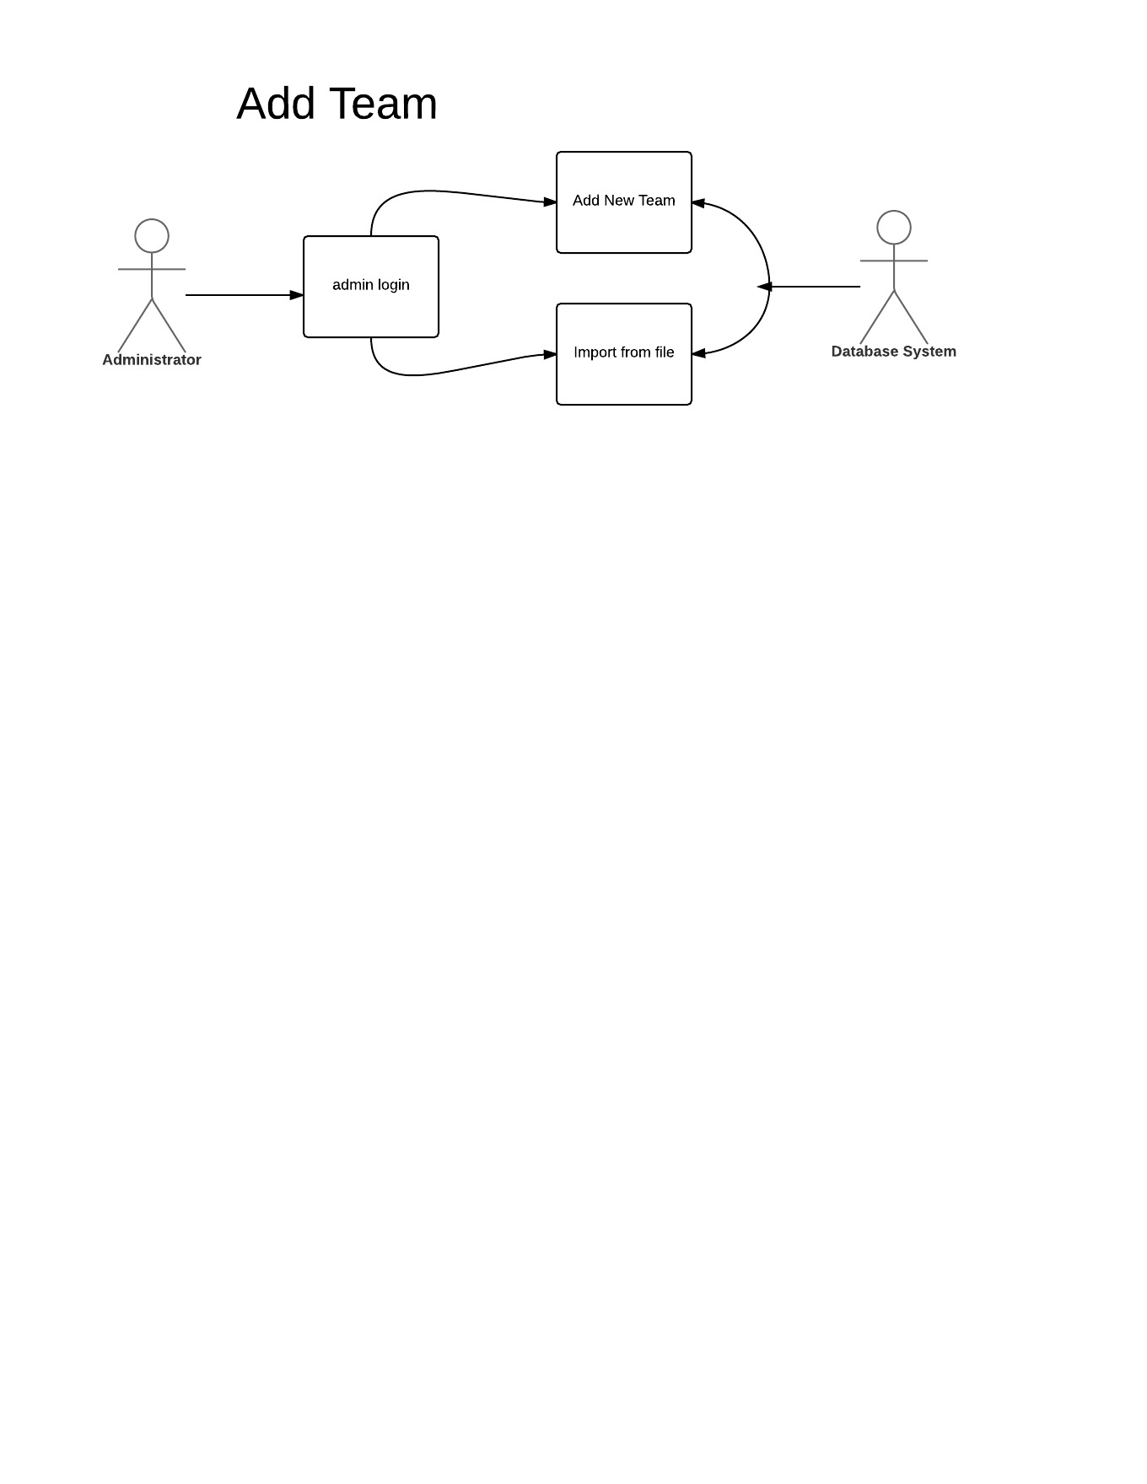

**Use case name: Add a new souvenir to an existing stadium**

Actors:

* Administrator (is allowed to edit, add, and remove from souvenir information database)
* Database System (process and manages the teams and souvenirs along with their corresponding stadium)

Triggers:

* The admin indicates that he/she wants to add a new Team/Stadium

Preconditions:

* The user is an administrator.

Post-conditions:

* A new team and corresponding stadium will be added to the database.

Normal Flow:

1. The admin enters ctrl + enter to get access to the Admin login and proceeds to enter the correct password.

2. The admin is presented with the itinerary management page.

3. The admin clicks on the “add team” button.

4. The system will prompt the admin enter name of the new team along with its corresponding stadium.

5. The admin clicks on the restart program button to verify the changes to the program.

Alternate Flows:

2A1: The admin can import data from file.

1. The admin clicks on the “add from file” button
2. The system prompts the admin to provide the pathway to the file
3. The use case returns to step 5 and continues.

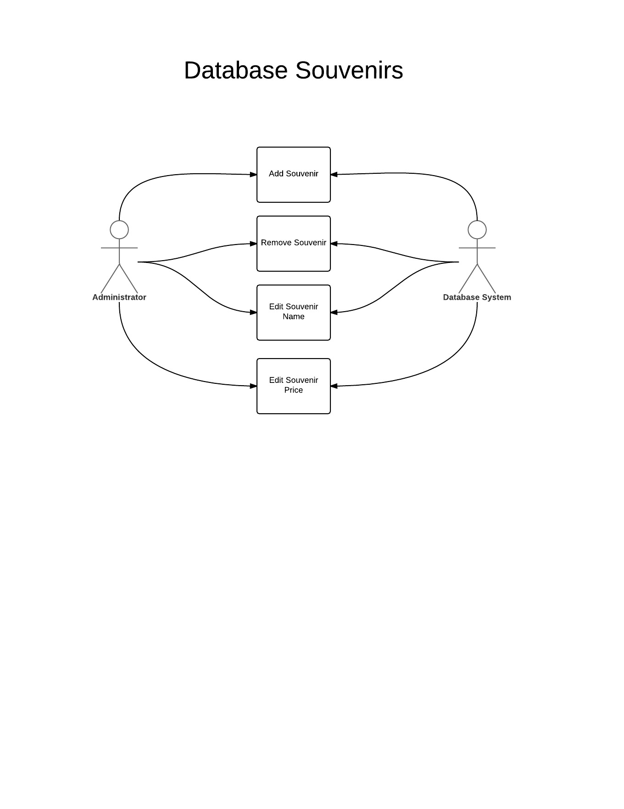**Use case name: Plan and Optimize a Trip**

Actors:

* Basic User (does not have admin access)
* Stadium/Team System (contains all the program data)
* Itinerary System (keeps track of all your planned stadiums to visit)

Triggers:

* The basic user launches the program and does not initiate admin login keystroke sequence.

Preconditions:

* All data in the program must be up to date and current

Post-conditions:

* User clicks the “Optimize” button

Normal Flow:

1). The user will launch the program

2). The user will click the “stadium information” (start) Button

3). The stadium system is displayed to the user.

4). The user will click on a stadium

5). The Stadium system displays specific field information along with corresponding souvenirs.

6). If the user wants to visit this stadium, they can select to add it to their custom itinerary, or select another stadium

7). When the user selects a stadium, a list of souvenirs on the bottom of the page appear, and allow the user to select which souvenirs they would like to purchase.

8). The stadium is added to itinerary system and the shopping cart system keeps track of the souvenir purchases made

9). The user clicks on the “Optimize” button and the itinerary system is optimized with stadiums in the shortest distance from one to the next.

10). The user clicks “Finalize”.

11). The user receives their optimized travel schedule

Alternate Flows:

4A1: The user clicks “Add All” button and adds all the restaurants from the Restaurant System to the Itinerary System

1. The user clicks on “Optimize and the Itinerary System is optimized with stadiums in

the shortest distance from one to the next

2. The user clicks on “Finalize”

3. The user receives their optimized travel schedule

